Birla Institute of Technology & Science, Pilani
Work-Integrated Learning Programmes Division
First Semester 2024-2025

Comprehensive Examination
(EC-3 Regular)

Course No. : AE ZG523
Course Title : PROJECT MANAGEMENT
Nature of Exam : Open Book
No. of Pages = 2

No. of Questions = 5
Weightage : 120 Marks
Duration : 2 Hours 30 Minutes
Date of Exam : Sunday, 01/12/2024 (AN)
Note:
- Please follow all the Instructions to Candidates given on the cover page of the answer book.
- All parts of a question should be answered consecutively. Each answer should start from a fresh page.
- Assumptions made if any, should be stated clearly at the beginning of your answer.

Question 1: (10 + 10 = 20)

- XYZ Retail, the world’s largest retailer, has successfully leveraged outsourcing in early 2000s as it was facing intense competition from other retailers. Discuss in what ways XYZ Retail must have done the outsourcing and what benefits it got from outsourcing?

- How do environmental factors affect project implementation? Also list two similarities and two differences between the cultures of United States and Japan.

Question 2: (10 + 10 = 20)

A. How does the culture of an organization influence the quality of estimates? Explain in a little detail.

B. Why should we separate performance reviews from pay reviews? How do we do it?

Question 3: (20)

For a typical project, the details of the normal duration, normal cost, crash duration and crash cost of each of the activities are given below.

Activity | Normal |  | Crash
Activity | Duration (days) | Cost (Rs.) | Duration (days) | Cost (Rs.)
(1-2) | 3 | 5,000 | 2 | 7,000
(2-3) | 4 | 6,000 | 2 | 12,000
(2-4) | 3 | 9,000 | 1 | 15,000
(2-5) | 4 | 5,000 | 3 | 9,000
(4-5) | 5 | 7,000 | 2 | 16,000
(3-5) | 3 | 8,000 | 1 | 9,500
(5-6) | 5 | 20,000 | 5 | 20,000

Assume indirect expenses to be Rs. 5000/day. Determine the minimum project cost and the associated duration. The project duration more than 14 days attracts a penalty of Rs. 1000 per day and the project duration less than 14 will be rewarded with a special bonus of Rs. 500 per day.

Question 4: (4+3+3+2+8 = 20)

The following table lists the activities of a network along with their time estimates and variances:

Activity Predecessor Weighted Average Activity Time Variance

A None 7 4
B None 11 16
C A 8 4
D A 5 1
E C 11 4
F D 7 4
G B 6 4
H E, F 5 1
I G 11 4
J H, I 0 0

- Draw the project network. Use activity on node (A-O-N) method.
- Identify the Critical Path. Calculate the length and variance of the Critical Path.
- Identify the non-critical activities. Work out the Total Slack (TS) and Free Slack (FS) for all the non-critical activities.
- State whether the network is sensitive or insensitive!
- What is the approximate probability that jobs on the critical path will be completed by the due date of (i) 34 days, (ii) 40 days?
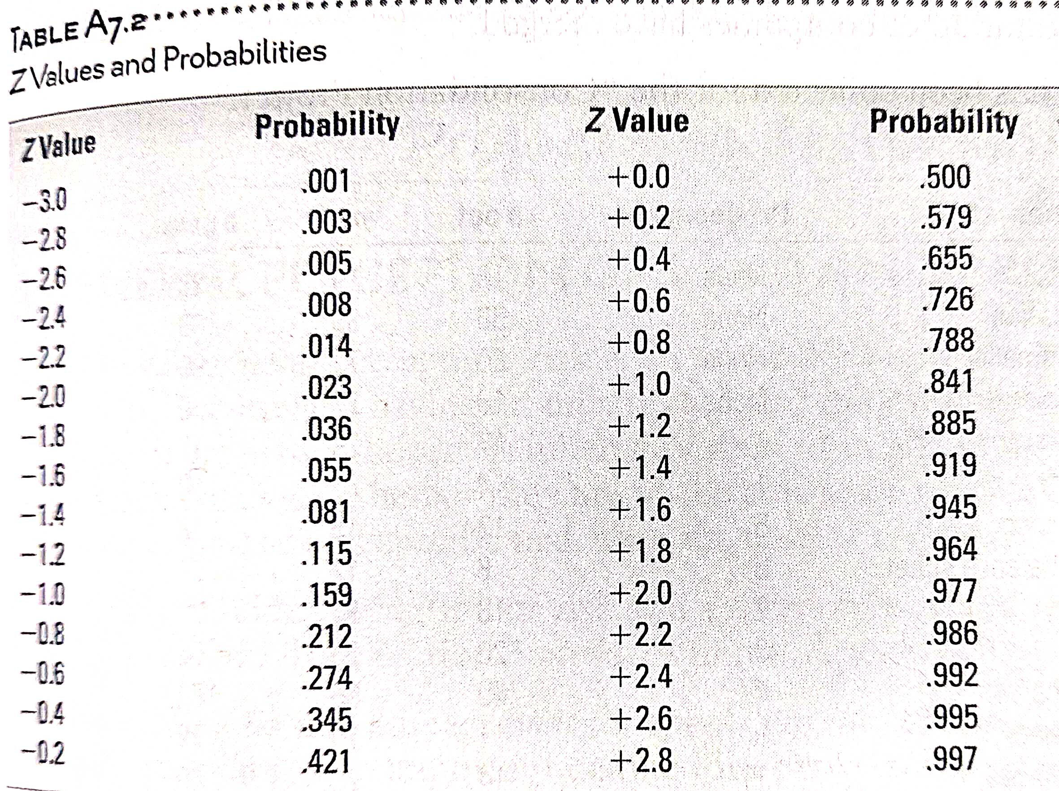

Question 5: (20)

The manufacturing firm is planning to setup a big manufacturing facility near Bengaluru to produce highly innovative four-wheeler focusing on the low-cost and sustainability. The design team is based out of Germany. The firm is a big firm with its presence in multiple countries. Prepare the risk register highlighting the risk source (at least 5 risk sources) along with likelihood and impact scores qualitatively by explaining each risk source in detail.

Question 6:
(20)

You are the project manager on a project that has $800,000 software development effort. There are two teams of programmers that will work for six months for a total of 10,000 hours. According to the project schedule your team should be done with 35% of the work. As of today, the project is 40% complete while 50% budget has been used. Calculate CV, SV, CPI, SPI, CSI, ETC, EAC, PCIC, PCIB, TCPI.

